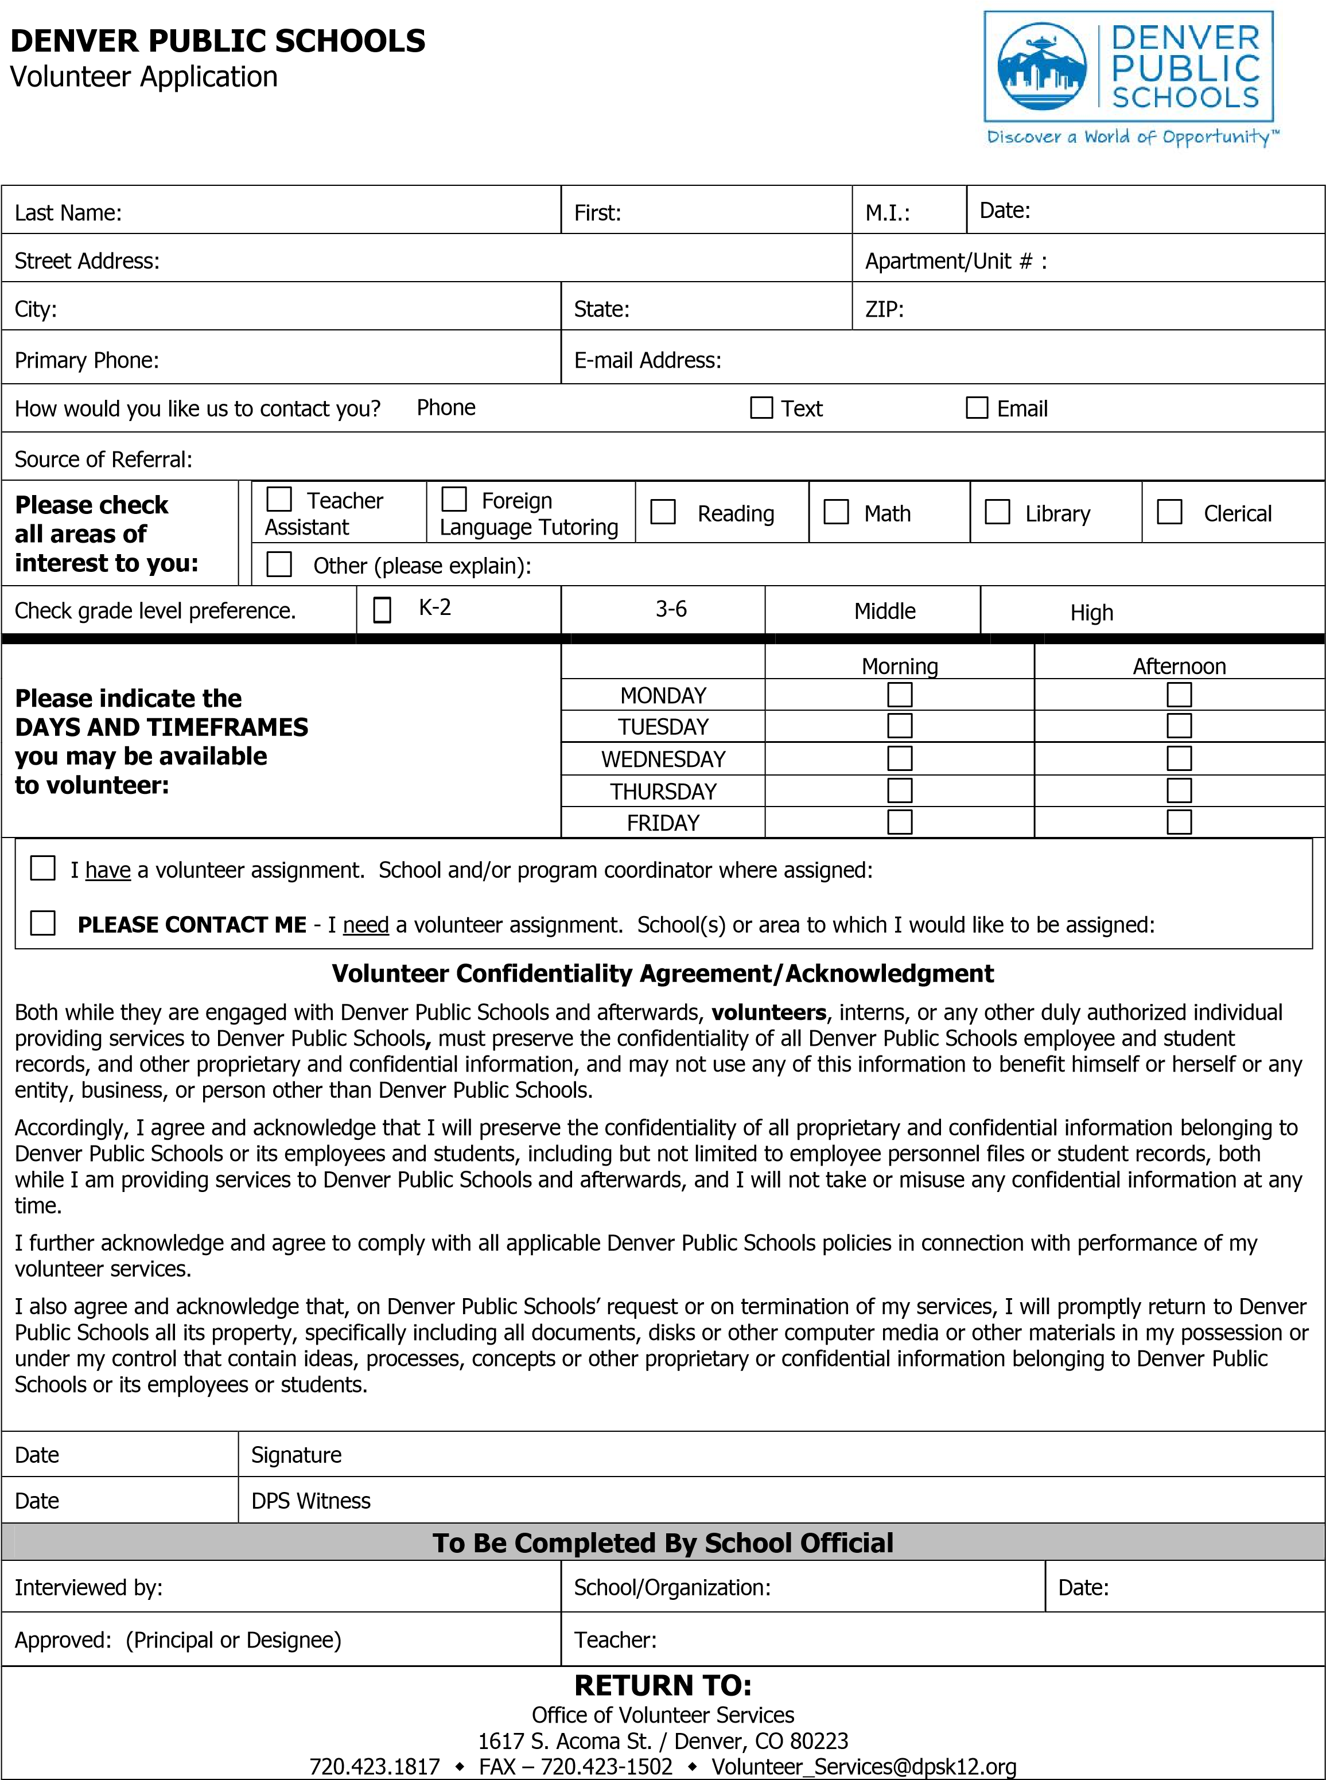

DENVER PUBLIC SCHOOLS - VOLUNTEER SERVICES
REQUEST FOR CRIMINAL HISTORY/BACKGROUND CHECK

PLEASE READ CAREFULLY
In an effort to encourage ongoing collaboration between Denver Public Schools and our families and community, the DPS Board encourages volunteering with Denver Public Schools. Completion of this form hereby authorizes Denver Public Schools to conduct a complete criminal background investigation of each volunteer applicant, which may include consultation with other federal/state law enforcement agencies and the Colorado Department of Education. Pursuant to this investigation, you may be contacted by representatives of the Denver Public Schools Safety & Security Department to arrange for submission of a complete set of fingerprints, as authorized by law, or provision of additional information regarding the investigation.
Note: a criminal conviction is not an automatic bar to volunteering. A volunteer applicant’s submission below of false or misleading information, or failure to disclose requested information, may disqualify the applicant from further consideration for volunteering, result in dismissal from volunteering if discovered at a later date, or cause Denver Public Schools to submit this application and investigation results to the district attorney for possible criminal prosecution. For purposes of the certification below, a “conviction” means any conviction by a jury or a court, any payment of a fine, a plea of “no contest”/nolo contendere, imposition of a “deferred” or “suspended” sentence, or forfeiture of any bail, bond or other security. “Misdemeanor” includes any drug or alcohol-related misdemeanor driving offense, but does not include any other misdemeanor traffic offense or traffic infraction.

PLEASE FILL OUT COMPLETELY. PLEASE PRINT CLEARLY AND LEGIBLY.
School/Program Applying For
Last Name Middle Name Date of Birth ¹
First Name

/
/
Driver’s Lic.# / Other
Photo ID

Telephone Number/s: Primary

Secondary

Please check one box:
NO, I have never been convicted of committing any felony or misdemeanor.;
YES, I have been convicted of the following felony(ies) or misdemeanor(s). List ALL:
Date | City/County/State | Charge(s)
Please list additional charges on a separate sheet if needed.
Please check one box:
NO, I have never been dismissed or resigned from employment or volunteer assignment following an allegation of unlawful behavior involving a child.
YES, I have been dismissed or resigned from employment or volunteer assignment following an allegation of unlawful behavior involving a child. Please explain:

Under the penalty of perjury, I hereby certify that all of the above information is true and correct to the best of my knowledge.
Volunteer Applicant’s Signature: Date:
Under the penalty of perjury, I hereby certify that I have viewed a valid governmental ID or a non-governmental ID accompanied by a form of ID issued by a governmental agency from the USA or another country, i.e., birth certificate for the above named volunteer and that I have witnessed the above named volunteer sign this application.
DPS Witness Signature: Date:
¹ It is at the district’s discretion to review and accept or reject any reasonable, valid identification on a case by case basis. Photo ID may include drivers license or identification cards from countries other than the United States of America. Non-governmental ID must be accompanied by a form of identification issued by a governmental agency from the USA or other country, i.e., birth certificate.
C.R.S. 24-10-103 (4)(a) (Colorado Governmental Immunity Rev 8/2016
Act)
DPS Office of Volunteer Services
1617 S. Acoma Denver CO 80223
720-423-1817 Fax – 720-423-1502
Volunteer_Services@dpsk12.org

